# Appendix D: MNIST Mini Problem

A simple way of illustrating how CNNs perform compared to more naïve methodologies is to show how CNNs work on a simpler problem. The MNIST handwritten digit dataset was chosen for this problem. The dataset consists of 60 thousand training images of 10 classes and 10 thousand of test images. Individual image size is 28x28 pixels.

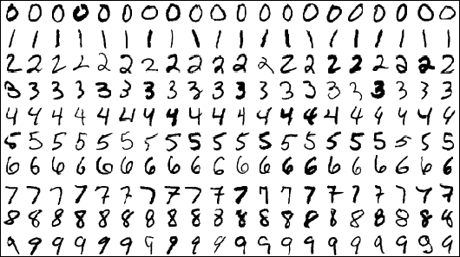

Figure : Some MNIST digit images

A network with two convolutional layers was used, each of which was followed by a pooling layer, and one fully connected layer (figure 2). Neuron dropout was applied in the fully connected layer to avoid overfitting.

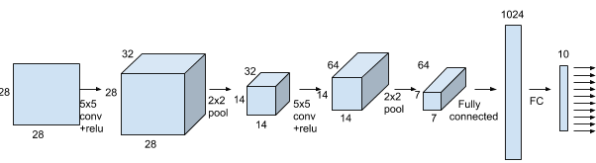

Figure : Network architecture for MNIST classifier CNN

A k nearest neighbor classifier is used to compare the performance of the CNN. The k-NN classifier uses the following parameters: k = 5 and Minkowski distance.

It is compared to the neural network (fig. 2) trained with 20000 steps, mini batch size 50, learning rate 10-4 and dropout probability 0.5. Using 10-fold cross validation on the data set we were able to calculate and compare accuracy of kNN vs the CNN implementation.

The accuracy for k-NN was 96.88%. With CNN we will get accuracy 99.18% which is approaching human error rate.